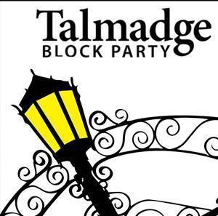 Talmadge Block Party 2018
Talent Show
Permission Slip

This slip with signatures on front and back is due by October 1, 2018.
Email to moore5@aol.com or deliver to 4710 Madison Avenue

Participant Name____________________________ Age___________

Parent’s Name______________________________ Email__________

Address____________________________________ Phone_________

Name of Act __________________________________________________

Description of Act: Circle: Individual or Group________________________________________
_____________________________________________________________________________
_____________________________________________________________________________
_____________________________________________________________________________

If a group, name all participants. Each participant must provide a separate, signed Permission Slip__________________________________________________________________________
_____________________________________________________________________________
_____________________________________________________________________________

**Parents: Please sign below that you are consenting to your child’s participation in the 2018 Talmadge Block Party Talent Show.
Parent’s Name (print)___________________________ Date__________
Signature___________________________________________________

QUESTIONS? Call Linda at 858-472-7606 or Lorrie at 858-245-8383.

Would you like to volunteer to help with the Talent Show and/or Talmadge Block Party?

Name________________________ Phone or Email_________________________

Physical Activity Release of Liability Form
I, ____________________________________________, hereby acknowledge my awareness that my participation in the Talmadge Block Party Talent Show and such activities may involve the following;
______________________________________________________________________________
(Description of Act)
I understand that my participation in the above-mentioned activities may expose me to certain foreseeable and unforeseeable risks of damage and/or bodily injury, including serious bodily injury, where I may need to be hospitalized.
I knowingly, freely and voluntarily assume all risks and engage myself in the participation of the above-mentioned activities.
I hereby release The Talmadge Block Party from any and all liability arising out my participation of the above-mentioned activities and hereby waive my rights herein to assert any claim(s) for damages, bodily injury or serious bodily injury to the fullest extend allowed by law.
I further agree that I will hold harmless The Talmadge Block Party against any and all claim(s) for damages, bodily injury or serious bodily injury arising out of or in connection of my participation in the above-mentioned activities whether caused by negligence or otherwise.
I fully understand the terms set forth in this form, and I hereby execute this Physical Activity Release of Liability Form.
____________________________________
Signature

_________________
Date
______________________________
Signature of Parent or Guardian

_________________
Date

